Task A:
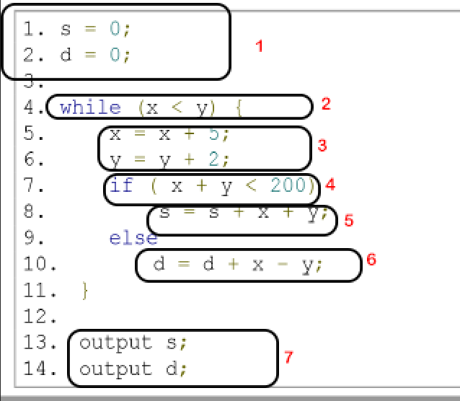
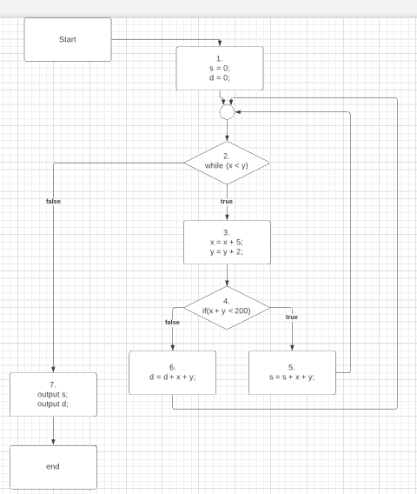
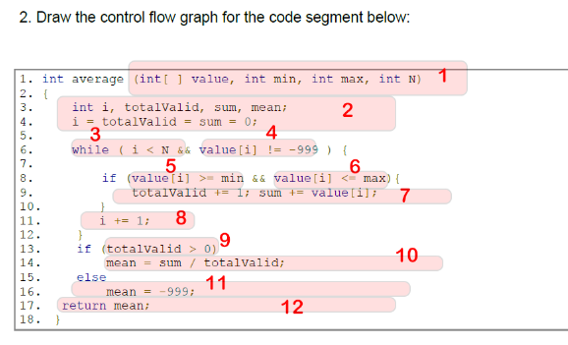
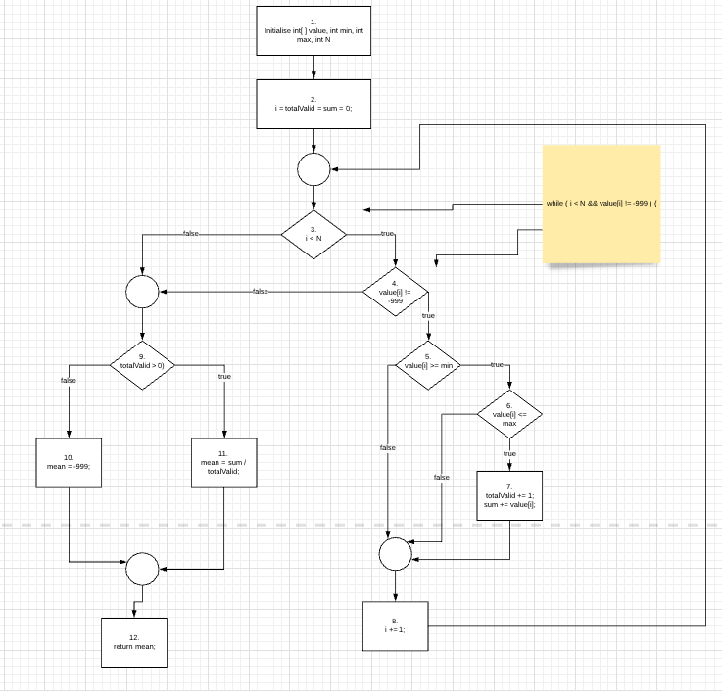

Task B:
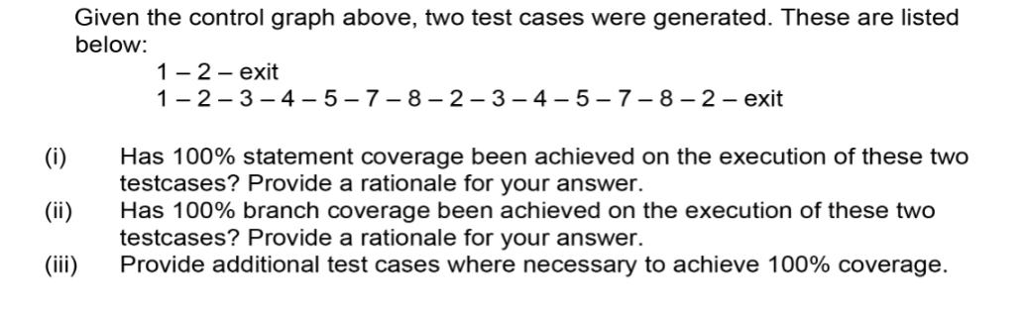
- No – Node 6 hasn’t been covered.
- No – Branches 4,5 and 6,7 haven’t been covered.
- 1 – 2 -3 – 4 – 6 – 7 – 8 – 2 - exit

Task C:
- Cc is 6, outer region + 5 other regions OR decisions points + 1 = 6
Bp1 | 1,2,3(T),4(T),5(T),6(T),7,8,3(F),9(F),10,12
Bp2 | 1,2,3(F), 9(T), 11, 12
Bp3 | 1,2,3(T), 4(F), 9(T), 11, 12
Bp4 | 1,2,3(T),4(T),5(F), 8, 3(F),9(F),10,12
Bp5 | 1,2,3(T),4(T),5(T),6(F), 8, 3(F),9(F),10,12

- For each path, discover the inputs and outs, an example of the process for a path is on the next page

Path:
1, 2, 3(T), 4(T), 5(T), 6(T), 7, 8, 3(F), 9(T), 11, 12
Path predicate:
3(T) i < N == true
4(T) value[i] != -999 == true
5(T) value[i] >= min == true
6(T) value[i] <= max == true
3(F) I < N == false
9(T) totalValid > 0 == true
Predicate interpretations:
Predicate interpretation is defined as the process of symbolically substituting operations along a path in order to express the predicate solely in terms of the input vector and a constant vector. So we are replacing local variables with constant variables.
What are the local values? I, sum and totalValid.
We must eliminate these with symbolic execution, let's replace these with constants by evaluating the code.
Node | Node Description | Interpreted Description
1 | Input vector  < int[ ] value, int min, int max, int N >
2 | i = totalValid = sum = 0;
3(T) | i < N | 0 < N
4(T) | value[i] != -999 | value[0] != -999
5(T) | value[i] >= min | value[0] >= min
6(T) | value[i] <= max | value[0] <= max
7 | totalValid += 1;  sum += value[i]; | totalValid = 0 + 1;  sum = 0 + value[0];
8 | i += 1; | I = 0 + 1
3(F) | i < N | 1 < N
9(T) | totalValid > 0 | 1 > 0
11 | mean = sum / totalValid; | mean = value[0] / 1
12 | return mean; | Return value[0]

Path predicate:
3(T) 0 < N == true
4(T) value[0] != -999 == true
5(T) value[0] >= min == true
6(T) value[0] <= max == true
3(F) 1 < N == false
9(T) 1 > 0 == true
Generate input from path predicate expression
N =1
Min = 0
Max = 100
value[0] = 2

Remember that mean = value[0] / 1.
Therefore out expected output for this input is 2.

For the path 1, 2, 3(T), 4(T), 5(T), 6(T), 7, 8, 3(F), 9(T), 11, 12
Our test case input is <{2},0,100,1> and our expected output is 2.

Repeat for the remaining paths

Task D:
Will delete for future workshops, its ugly Sorry!

